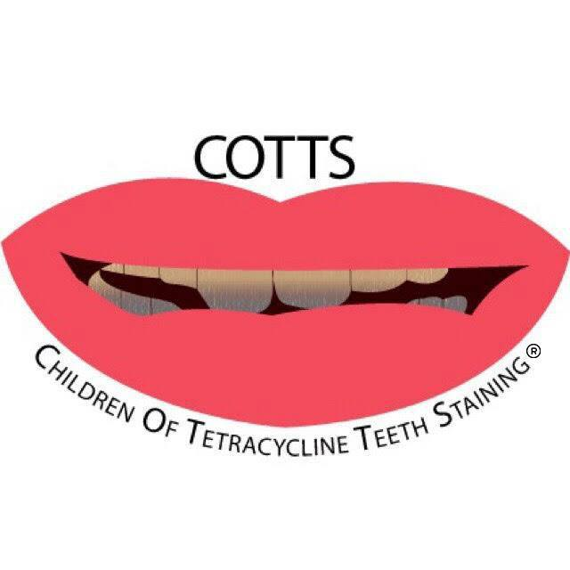
COTTS SMILE RESTORATION APPLICATION
Children Of Tetracycline Teeth Staining (COTTS) connects victims of Tetracycline Teeth Staining who would like the chance to have restorative cosmetic dentistry. The dental injuries need to be a direct result of the side effect from the antibiotic drug, Tetracycline. In addiction with your completed application, Children of Tetracycline Teeth Staining, Inc. (COTTS) will require a form from your dentist(s) indicating you have suffered from Tetracycline Teeth Staining. A current photograph is mandatory for your Smile Restoration Application. If you have had any cosmetic dentistry in recent years it is also mandatory to include photograph(s) of your previous tetracycline teeth damage. All dental services will be subject upon approval from Children Of Tetracycline Teeth Staining, Inc.

WHO IS ELIGIBLE FOR A COTTS SMILE RESTORATION SERVICE?
Any person who has suffered from the side effects of Tetracycline Teeth Staining.

  - Must be 18 years of age
  - Must have dentist verify teeth staining/discoloration is the direct result of the side effect from Tetracycline
  - Must provide photograph(s) of damaged teeth
  - Must have privacy release form signed by applicant
  - Must submit a $20.00 Non-refundable (PayPal, money order or pay over the phone) Application Fee to:
*** To pay the $20.00 application fee through paypal:
www.paypal.me/cottsapplication/20

# (727) 457-1960

Children Of Tetracycline Teeth Staining, Inc.
P.O. Box 1121
New Port Richey, Fl. 34656

cottsorg@gmail.com
CHILDREN OF TETRACYCLINE TEETH STAINING (COTTS) HELPS WITH THE FOLLOWING SMILE RESTORATIVE SERVICES:

- Clip-on Veneers
- Whitening
- Cleaning and exams
- Veneers
- Bonding
- Caps
- Crowns
- Implants
- Extractions
- Dentures

*All services are subject to change or modified based upon the dentist recommendations.

CHILDREN OF TETRACYCLINE TEETH STAINING (COTTS) DOES NOT HELP WITH THE FOLLOWING:

- Does not help with cavities, fillings, gum disease, jaw injuries, TMJ, root canals, dry socket, anesthesia, fluoride or orthodontic treatment.
- Does not replace or fix dental work not attributed to tetracycline Teeth Staining affliction.
In other words, dental work that does not fit, looks bad, no longer works, and an implant that was started and not completed or any dental work that has been completed in the past.

*All services and are subject to change or modified based upon the dentist recommendations.

PLEASE NOTE: Read this entire application carefully before completing it. If the application is not signed and dated and all pages are not completed, it will be delayed or possibly rejected. Should you have any questions please email us at COTTSorg@gmail. In the subject line include word “Application.” Thank you.

COTTS SMILE RESTORATION APPLICATION
PLEASE PRINT
1. First Name: _____________________ Middle Initial: _____ Last Name: _________________________
2. Date of Birth: _____________________ 3. Gender with which you identify: _______Male____Female
4. Mailing Address: __________________________________________________________________________________________________________________________________________________________________________
City: ____________________________ State: ______________________Zip Code: _________________
6. Phone: Cell phone:

7. How did you hear about our program?
_________________________________________________________________________________________________________________________________________________________________________________________________________________________________________________________________________________________________________________________________________________________________________________________________________________________________________

8. We understand the severity of living with Tetracycline Teeth Staining, please explain about your personal story and how Tetracycline Teeth Staining has affected your life.
________________________________________________________________________________________________________________________________________________________________________________________________________________________________________________________________________________________________________________________________________________________________________________________________________________________________________________________________________________________________________________________________________________________________________________________________________________________________________________________________________________________________________________________________________________________________________________________________________________________________________________________________________________________________________________________________________________________________________________________________________________________________________________________________________________________________________________________________________________________________________________________________________________________________________________________________________________________________________________________________________________________________________________________________________________

9. List all the dental issues in your entire mouth:
_____________________________________________________________________________________________________________________________________________________________________________________________________________________________________________________________________________________________________________________________________________________________________________________________________________________________________________________________________________________________________________________________________________________________________________________________________________________________________________________________________________________________________________________________________________________________________________________________________________________________________________________________________________________________________________________________________________________________________________________________________________________________________________________________________________________________________________________________________________________________________________________________________________________________________________________________________________________________________________________________________________________________________________________________________________________________________________________________________________________________________

10. Have you previously had dental work done (such as whitening, bonding, veneers, caps, bridges, etc.)?
Yes___________ No___________ If Yes, Date(s): ___________________________________________
___________________________________________
___________________________________________
__________________________________________
__________________________________________

If Yes, list Dentists, locations, and office number(s) you’ve been to and explain dental procedures:
___________________________________________________________________________________________________________________________________________________________________________________________________________________________________________________________________________________________________________________________________________________________________________________________________________________________________________________________________________________________________________________________________________________________________________________________________________________________________________________________________________________________________________________________________________________________________________________________________________________________________________________________________________________________________________________________________________________________________________________________________________________________________________________________________________________________________________________________________________________________________________________________________________________________________________________________________________________________________________________________

11. Estimate the amount of money you’ve spent to fix your discolored teeth? ________________________________________________________________________________________________________________________________________________________________________________________________________________________________________________________________________________________________________________________________________________________________________________________________________________________________________ ______________________________________________________________________________________________________________________________________________________________________________________________________________________________________________________________________________________________________________________________________________________________________________________________________________________________________________________________________________________________________________________________

12. What specifically would you like help with regarding your Smile Restoration Makeover?
_____________________________________________________________________________________ __________________________________________________________________________________________________________________________________________________________________________________________________________________________________________________________________________________________________________________________________________________________________________________________________________________________________________________________________________________________________________________________________________________________________________________________________________________________________________________________________________________________________________________________________________________________________________________________________________________________________________________________________________________________________________________________________________________________________________________________________________________________________________________________________________________________________________________________________________________________________________________________________________________________________________________________________________________________________________________________________________________________________________________________________________________________________________________________________________________________________________________________________________________________________________________________

Please Initial:
13. ______ I ensure that I’ve attached photo(s) regarding my Smile Restoration Application.

14. ______I understand that my $20.00 application fee is non-refundable.

15. ______I give permission for Children Of Tetracycline Teeth Staining, Inc. to share information about my application. *Program eligibility requirements are subject to change.

SIGNATURE: _________________________________________________ Date: ________________

Print Name: __________________________________________________ Date: ________________

Patient Agreement Form:
Please initial next to each statement below and sign at the bottom, letting us know that you understand Children Of Tetracycline Teeth Staining’s Smile Restoration Application process.

_______Based on my situation, I verify that I have suffered from Tetracycline Teeth Staining side effects.
_______The dental work I may receive is donated by Children Of Tetracycline Teeth Staining, Inc.
_______ My $20.00 application fee is non-refundable.
_______ Sending in an application to Children Of Tetracycline Teeth Staining, Inc. does not guarantee I will be awarded Smile Restoration Services.
_______ I agree to perform all duties set forth by this non-profit that may arise with respect to my participation in the program.
_______ COTTS does not help with cavities, fillings, gum disease, jaw injuries, TMJ, anesthesia, dry socket or orthodontic treatment (braces, shifted teeth, and/or spaces between teeth).
_______ COTTS does not replace or fix dental work (such as dental work that does not fit, looks bad, no longer works, an implant that was started but not completed or any work that has been completed in the past).
_______ COTTS does not guarantee specific dental work I want.
_______ I can be disqualified from Smile Restoration Services if I don’t comply with COTTS guidelines and requirements.
_______ I will update COTTS, Inc. of any changes to my phone number(s) or mailing address.
_______ If I’m eligible for COTTS Smile Restoration Services, once my Smile makeover is complete, I will send “after” photo(s) of the completed dental cosmetic procedure.
_______ I give COTTS permission to review and disclose my dental history from past, present, and future dental practices (including images).
_______ I have read this agreement form and understand that if I do not follow these guidelines, I can be disqualified from the program.

Signature: ___________________________________________________ Date: ___________________

Print Name: ________________________________________________ Date: ____________________

Tetracycline Teeth Staining Verification Form (To Be completed by Dentist):

__________________________________ confirms that I have met with the applicant at least once.
Based solely on my Professional opinion, _________________________________ has suffered from side
effects of Tetracycline Teeth Staining. I understand that I may be contacted regarding this information.

Signature: _____________________________________________ Date: ________________________

Print: ________________________________________________ Date: ________________________

Name of Dental Practice: ________________________________________________________________
Office Manager: _______________________________________________________________________
Professional License Number (and/or stamp): _____________________________________________________________________________________
Web Address: _________________________________________________________________________
E-mail Address: ________________________________________________________________________
Phone: _______________________________________ Fax: ___________________________________
Address: ___________________________________________________
City: ____________________________ State: ____ Zip Code: ________

Would you like COTTS.org to send program literature to your business? ______Yes ______No
INFORMATION AND PHOTOGRAPH RELEASE FORM

I hereby grant Children Of Tetracycline Teeth Staining, Inc. (COTTS) the irrevocable right and permission to use my information and photographs/videos pertaining to my Smile Restoration Application. The use of my personal photographs/videos and story about me in publications, websites, research data, promotional flyers, educational materials, derivative works, or for any other similar purpose without compensation to me.

I understand and agree that such information and photographs/videos of me may be placed on the Internet. I also understand and agree that I may be identified by name and/or title in printed, Internet or broadcast information that might accompany the photographs/videos of me. I waive the right to approve the final product. I agree that all such portraits, pictures, photographs/videos shall remain the property of Children Of Tetracycline Teeth Staining, Inc. (COTTS).

I hereby release, acquit and forever discharge Children Of Tetracycline Teeth Staining, Inc., its board, staff, trustees, agents, donors, contributors, officers and employees of the above-named entities from any and all claims, demands, rights, promises, damages and liabilities arising out of or in connection with the use or distribution of information and photographs/videos, including but not limited to any claims for invasion of privacy, appropriation of likeness or defamation.

I hereby warrant that I am eighteen (18) years old or more and competent to contract in my own name or, if I am less than eighteen years old, that my parent or guardian has signed this release form below. This release is binding on me and my heirs, assigns and personal representatives.

_______________________________________________________ ______________________
Signature Date

_______________________________________________________
Print Name

If individual photographed/recorded is under eighteen (18) years old, the following section must be completed: I have read, and I understand this document. I understand and agree that it is binding on me, my child (named above), our heirs, assigns and personal representatives. I acknowledge that I am eighteen (18) years old or more and that I am the parent or guardian of the child named above.

____________________________________________________
Printed Name Of Patient

____________________________________________________ ____________________________
Signature of Parent Date

___________________________________________________
Printed Name of Parent/Guardian

“The Smile That Was Frowned Upon”

